Big Data Analysis and Cross-Layer Optimization for Communication, Caching and Computing Networks
Zhu Han, ECE Department and CS Department, University of Houston
Abstract:
The recent advances of computing, caching, and communication (C^3) can have significant impacts on the future network design. In addition, there are many new technologies for big data analysis and cross-layer optimization. In this talk, we limit our scope to three specific cases, while want to give insights. First, a new formulation for bandwidth allocation and routing problem is formulated for wireless network virtualization, and the decomposition algorithms are constructed using the alternating direction method of multipliers that can be implemented in a parallel and distributed fashion. Second, the caching based D2D communication scheme is investigated by taking social ties among users and common interests into consideration, and the hypergraph and matching frameworks are employed for optimization. Third, we consider mobile social networks together with C^3 networks using deep learning to study social networks and a novel deep reinforcement learning approach to automatically make a decision for optimally allocating the network resources.
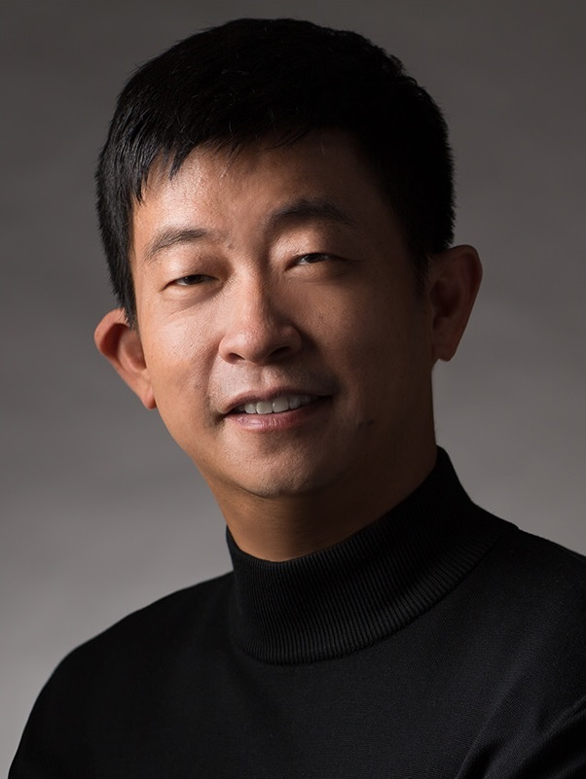
Bio: Zhu Han received the B.S. degree in electronic engineering from Tsinghua University, in 1997, and the M.S. and Ph.D. degrees in electrical engineering from the University of Maryland, College Park, in 1999 and 2003, respectively. From 2000 to 2002, he was an R&D Engineer of JDSU, Germantown, Maryland. From 2003 to 2006, he was a Research Associate at the University of Maryland. From 2006 to 2008, he was an assistant professor in Boise State University, Idaho. Currently, he is a John and Rebecca Moores Professor in Electrical and Computer Engineering Department as well as Computer Science Department at University of Houston, Texas. His research interests include security, wireless resource allocation and management, wireless communication and networking, game theory, and wireless multimedia. Dr. Han is an NSF CAREER award recipient 2010. Dr. Han has several IEEE conference best paper awards, and winner of 2011 IEEE Fred W. Ellersick Prize, 2015 EURASIP Best Paper Award for the Journal on Advances in Signal Processing and 2016 IEEE Leonard G. Abraham Prize in the field of Communication Systems (Best Paper Award for IEEE Journal on Selected Areas on Communications). Dr. Han has been IEEE fellow since 2014, AAAS fellow since 2020 and IEEE Distinguished Lecturer from 2015 to 2018. Dr. Han is winner of 2021 IEEE Kiyo Tomiyasu Award, and has been 1% highly cited researcher according to Web of Science since 2017.

